The Windmill Centre - Fire Safety Risk Assessment

Description of Premises
The Windmill Centre is a conventional build single-story community building situated in Pendennis Road in the middle of Hele village Torquay. The Hall is a registered charity and is run by a Management Committee of local volunteers. The committee consists of representatives from user groups and elected members of the public.

The facilities comprise the Main Hall, the Training Room, the computer suite, a dedicated counselling room, the Main Office, an entrance lobby and separate men’s, women’s and disabled toilets. The Main Hall and Training Room has a catering kitchen attached to it. The Hall is available to hire for both private and public events. The Main Hall can hold up to 100 and the Training room is suitable for much smaller groups, maximum 20 people. The centre also has a maximum occupancy limit of 150 for insurance purposes.

There is a car park to the side of the building, with space for 14 cars (plus 1 disabled space). There are 2 double door emergency exits leading directly out of the building from the Main Hall, and the main doors from the foyer are the other emergency exits. The premises meet all the requirements of the current Disability Discrimination Act and are licensed for entertainments including dance, plays, films and music.

The Hall is hired by a range of voluntary organisations, private individuals and statutory organisations for a variety of activities for a wide range of community needs. A verbal agreement between The Windmill Centre and the Hirer forms the basis of the Hiring arrangement. The Hire Agreement and Standard Conditions of Hire draw the hirers’ attention to the health and safety that the booking places upon them.

Principal Uses of The Windmill Centre
The Windmill Centre is used for a wide variety of functions. These cover, but are not limited to, Chronic Pain Café, Catch Up Café, S.P.A.C.E. Dog Training, Christian Church and Men Rok.

The Windmill Centre Management Committee encourages all regular users of the Hall to carry out their own Fire Risk Assessment, highlighting the areas that pertain to their own group of users and their activities.

The Management Committee encourages hirers to make themselves aware of the exit routes, the fire extinguishers and other equipment and the plan of the Hall detailing the location of the equipment and the escape routes. The plan is available to all Hall users, is published on the web site and is also on the notice boards of the Main Hall and other rooms in the building.

People at Risk of Fire
Staff: The Windmill Centre staff and office volunteers are all briefed and trained on fire evacuation procedures and know where the fire assembly point is.
Trades People: The committee employs local trades people on both an ad-hoc and scheduled basis for the purposes of cleaning, safety checks and building maintenance. The cleaner has a key to the building and is generally on her own when working. Local trades people who are familiar with the building may gain access to the Hall by borrowing a key from the centre manager or other committee member, while others are always escorted by one or more committee members or volunteers.

Hall Users (up to 150 max. at any time): These will generally be familiar with the Hall. Those that are not will find the simple layout easy to navigate and assimilate. The Main Hall area is open plan and has 2 easily identifiable fire exits and a third exit adjacent to the boiler room and kitchen. Emergency lighting is installed over fire doors and around the Hall, and this is tested regularly. A fire alert and detection system with audible sounders is installed, and this is tested regularly. There are fire doors fitted with push-bar releases that exit directly outside at the rear of the Main Hall. The main double entrance doors to the Hall must be kept unlocked whenever the Hall is in use for a function.

Disabled Persons: At a typical function there may possibly be a limited number of disabled persons. It is the responsibility of Hall hirers to ensure disabled persons are given adequate assistance in the event of an evacuation. Emergency exit doors in the Main Hall have access ramps suitable for wheelchair use. The double doors at the entrance to the centre has a Disabled Access button operated door and also a pair of conventional aluminium framed double doors for ease of evacuation if required.

Children: It is the responsibility of hirers to ensure all children within the Hall are supervised and that they are given adequate assistance in the event of an evacuation.

Other Members of the Public (who are not using the Hall): Members of the public may walk past the front of the Hall and through the car park.

Possible Causes of Fire

Source of Ignition | Source of Fuel | Source of Oxygen
Faulty electrical system in mains power supply, ring mains or lighting  circuits. | Any material close to the source of the fault (e.g. the cupboard in which the consumer unit is located, skirting boards, plaster board, wood  panelling). | Open to the air
Gas leak in mains supply  to boilers. | Any combustible materials close to the boilers (in  the Small Hall) | Open to the air
Faulty portable electrical equipment (e.g. kettles,  toasters, radios, etc) | The portable device itself and then any combustible materials close to it | Open to the air
Kitchen appliances (i.e.  hob, oven, fridge, kettle, microwave) | The appliance itself and then any combustible materials close to it | Open to the air
Smoking | Material in waste bins or any other areas where  cigarettes may be left or disposed of. | Open to the air
Cooking accidents | Hot oil igniting on the hob or under a grill. Food  burning in the oven or on the hob. | Open to the air
Arson | Could be any source | Open to the air

Candles and other naked  flames | The candles and combustible materials close to  them. | Open to the air

Control Measures

Fire hazard | Like- lihood 1=low  5=high | Risk to people from fire hazard | Measures to avoid or reduce
 |  |  | The hazard | Risk to people
Fire inside the Hall | 2 | Smoke inhalation. | Ensure sufficient and correct fire fighting equipment is available and that a qualified practitioner inspects it at least once per year and provides advice on changing or moving locations as appropriate. The location of fire-fighting equipment and exits are clearly marked on a plan of the Windmill Centre, which is published on the notice boards.  A test of continued illumination in event of a power failure will be done quarterly.  Ensure that Windmill Centre furnishings are made of a non- combustible material or a material that has been Fire Proofed to the standard applicable at the time of purchase. This includes window curtains, chairs, etc. Hall users will be asked to remove all their rubbish when they leave the building (i.e. emptying any bins) | Ensure Hall users/hirers know how to evacuate the building, where the fire-fighting equipment is located and where the assembly points are. A fire alert system has been installed so that an alarm can be raised if a fire is discovered; it also includes heat detection in the room most at risk – the kitchen. Ensure the hirers know that they must organize a fire martial to check the building has been vacated after alarm and that the fire brigade has been called out (as appropriate). Ensure all Fire Exit doors are checked for illumination, ease of opening and that the Emergency Exit Routes are clear on a weekly basis. The Management Committee tests the ease of access to and through the escape routes and to the assembly points at least once per year and logs the results.  Users will be made aware of  their responsibilities under the Premises License (via the Booking process). Regular User Groups will be advised that they should carry out their own Risk Assessment and that a copy should be lodged with the  Management Committee.
 |  | Burns.
 |  | Death.
 |  | Particular attention to be paid to people who are sleeping overnight or attending large events.
Fire on the | 1 | Evacuating |  | Ensure hirers understand and
premises |  | people |  | accept their responsibility to
outside the |  | towards the |  | evacuate the building in the
Hall. |  | source of the |  | event of a fire and to allocate a
 |  | fire |  | responsible person to ensure
 |  |  |  | the evacuation is coordinated
 |  |  |  | properly and safely.

Faulty electrics in mains power supply, ring mains, lighting circuits, kitchen appliances or portable  devices. | 1 | Electrocution while attempting to put out the fire with water. | A qualified practitioner checks the fixed wiring once every 3 years and portable appliances are checked every year. A Certificate of Inspection will be obtained for each inspection. | Ensure suitable (not water) fire fighting equipment is available close to the likely sources of electrical fires.
Gas leak in mains supply to boilers, oven and water heaters | 1 | Death from explosive combustion and associated  damage. | Ensure that the gas appliances are is maintained and tested at least once per year. A safety inspection certificate to be obtained after each service.
Smoking | 3 | Smoke inhalation. Burns. | A No Smoking policy enforced throughout the premises. No Smoking signs strategically placed throughout the  building.
Cooking accidents | 3 | Smoke inhalation. Burns. | Ensure users are aware of appropriate safety precautions concerning the use of the cooker. No deep fat fryers allowed. Ensure there is a fire blanket available close to the  hob, for putting out oil fires.
Children playing with matches or  other combustibles | 2 | Smoke inhalation. Burns. |  | Ensure hirers are aware of their responsibility to supervise children while inside the Hall.
Arson | 1 | Smoke inhalation. Burns. | Ensure Hall hirers are aware of their responsibility for the Hall during their occupation and take reasonable steps to prevent wilful damage and  lock up on departure. | Wherever possible, locking mechanisms for ensuring internal safety without comprising emergency routes are fitted.

Fire Assembly Point:
The Car Park

Plan of the Hall:

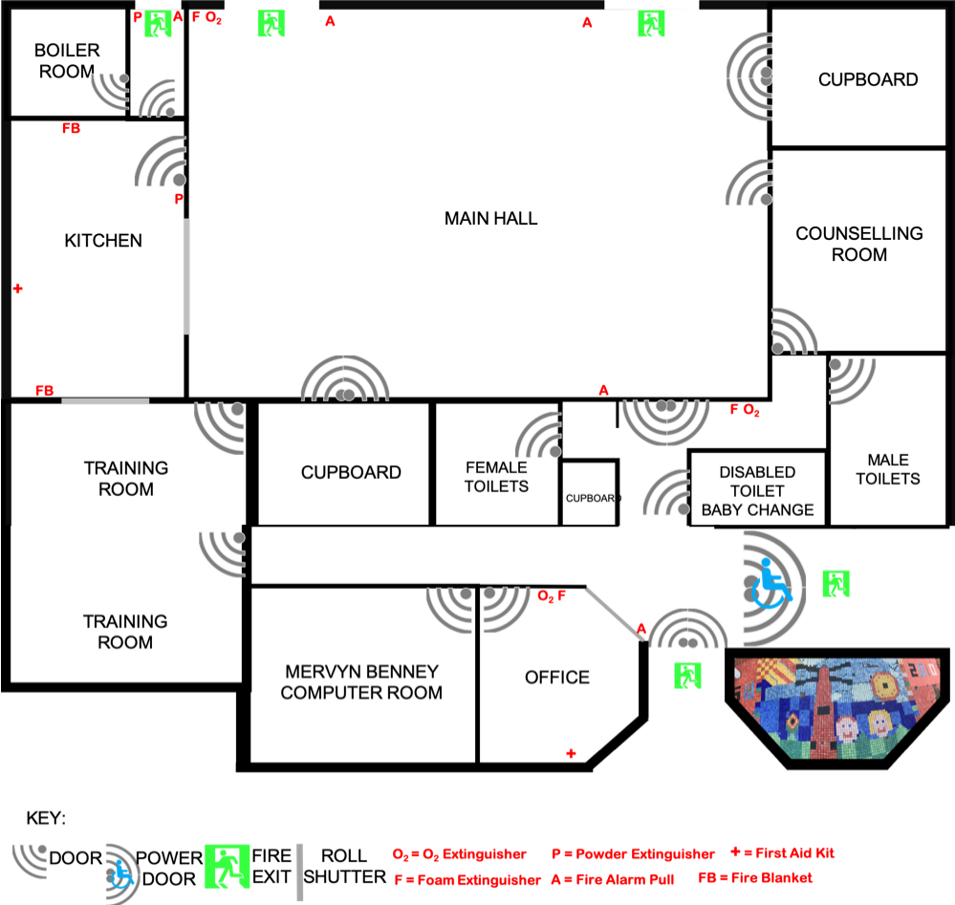

Initially approved by the The Windmill Centre Management Committee July 2017 Reviewed annually by the Management Committee

