Walnut, date and honey cake

Ingredients:
225g  ½ tsp  175g  100g  3 tbsp  2  2  100g  50g | Self-raising flour  Ground cinnamon  Softened butter  Light muscovado sugar  Clear honey  Eggs  Ripe bananas  Chopped Dates  Chopped Walnuts

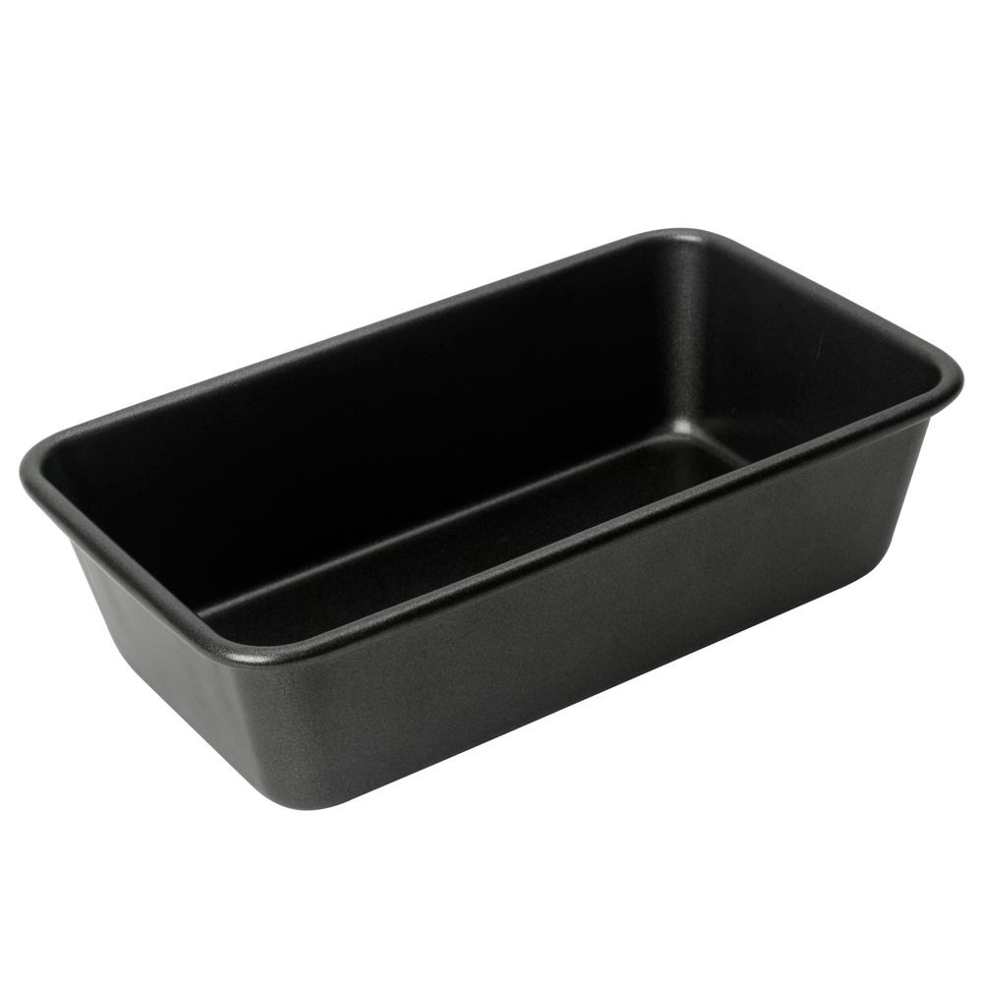
Method:

  - Preheat an oven to 160C and grease a 2lb loaf tin
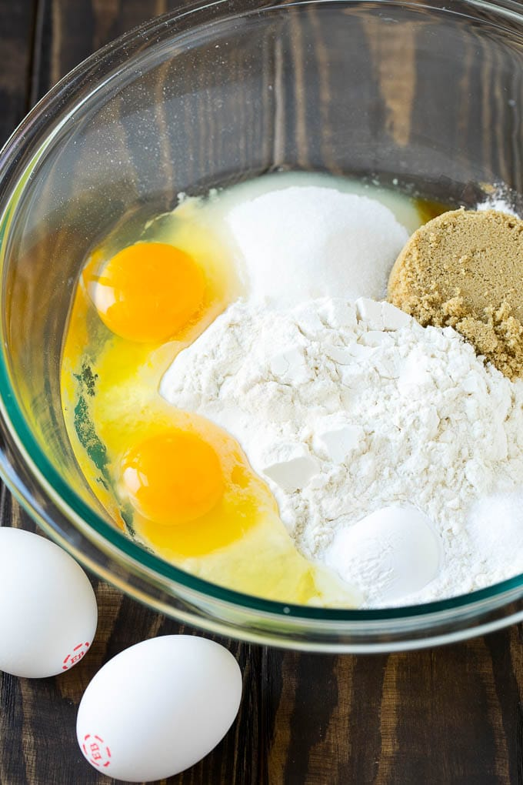
  - In a large bowl mix in the flour, cinnamon, butter, honey and eggs.

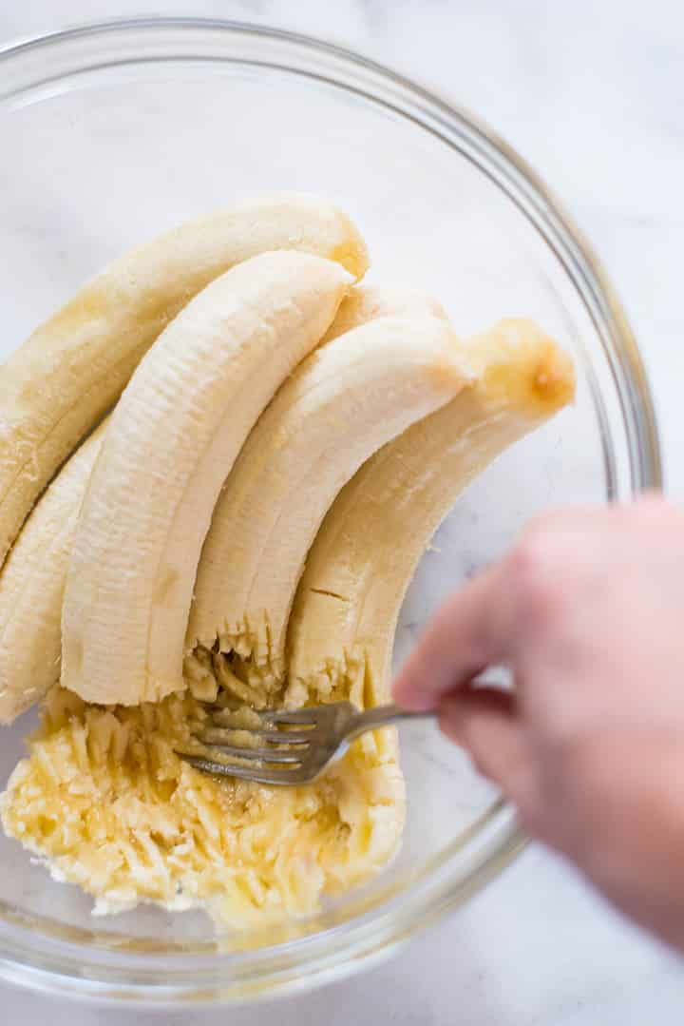

  - Then to the bowl mash in the bananas and dates and mix for 3 minutes either using a blender or a wooden spoon.

  - Spoon the mixture into the loaf tin and cover with pieces of walnut.

  - Bake for 1 hour until the cake feels firm. Leave to cool for 15 minutes before serving with a cuppa

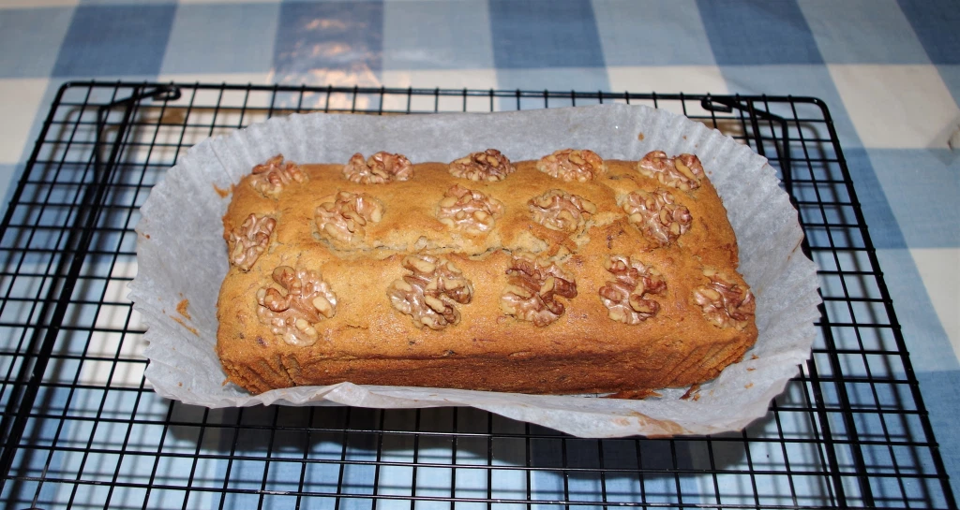

Please remember to send in your photos of you cooking the recipe and the finished product. Send pictures in to alanrtilley@mail.com or text them across to 07817777739

