Orzo and tomato soup

Ingredients:
1  2  2  1 tbsp  1  1  150g  700ml  2 tbsp | Chopped onion  Chopped celery sticks  Crushed garlic cloves  Tomato puree  Can of chopped tomatoes  Can of chickpeas  Orzo pasta  Vegetable stock  Basil pesto

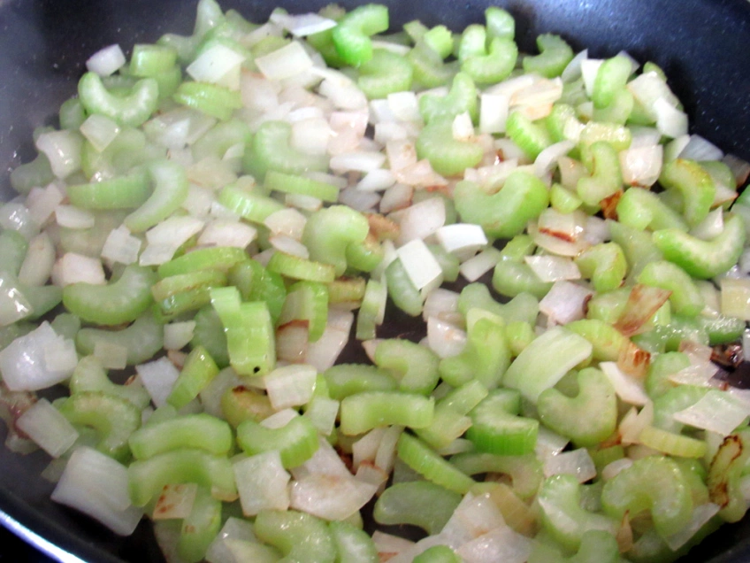
Method:

  - Add a little oil to a saucepan and cook the chopped onion and celery for 10 – 15 minutes on a low heat until soft.

  - To the onion and celery add the crushed garlic and continue to heat for 1 minute.

  - Stir in the tomato puree, chopped tomatoes, chickpeas, pasta and vegetable stock. Bring to the boil and then simmer for 8 minutes.

  - Stir in the pesto at the end and then serve in bowls with crusty bread

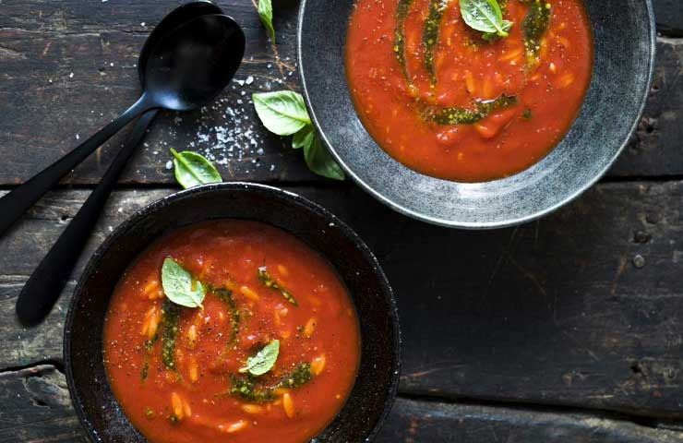

Please remember to send in your photos of you cooking the recipe and the finished product. Send pictures in to alanrtilley@mail.com or text them across to 07817777739

