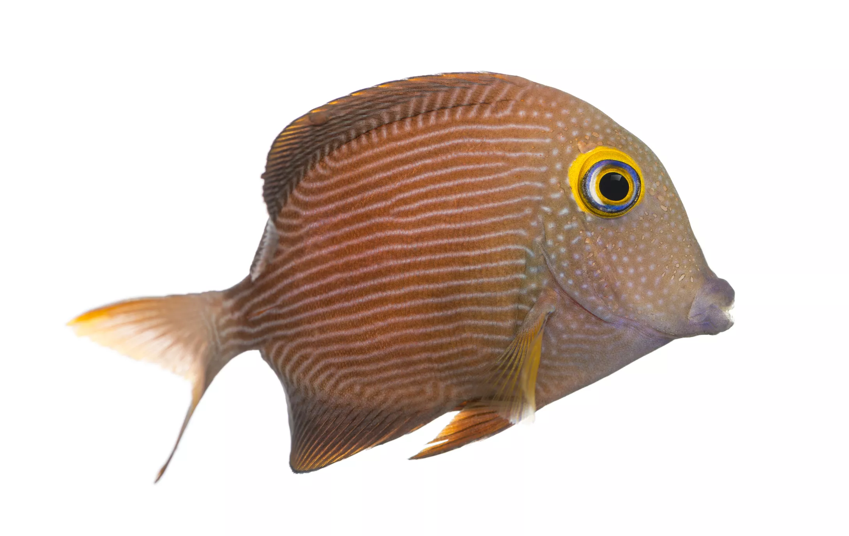
Fishy fish cakes

Ingredients:
300g  1  2 tbsp  3  1  2 tbsp  2 tbsp  1 tbsp | Potatoes cut into chunks  Can of sardines  Chopped parsley  Chopped spring onions  Zest and juice of a lemon  Mayonnaise  Greek yoghurt  Plain flour

Method:
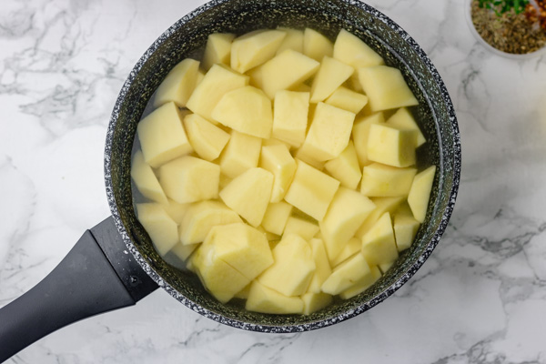
  - In a large pan cook the cubed potato in boiling salty water for about 15 minutes until soft.

  - In a large bowl mash the sardines, chopped spring onions and parsley. Cut the lemon in half and to the bowl add the zest and juice of half of the lemon.

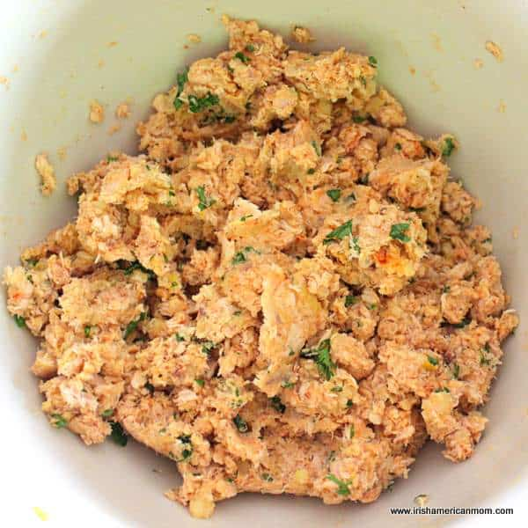
  - Drain the potato and add this to the bowl of mashed sardines. Mix and shape into 4 fish cakes.

  - In a little bowl add the yoghurt, mayonnaise and the remaining lemon juice and zest.

  - Put a little oil in the base of a frying pan and heat the fish cakes on a high heat for 4 minutes on each side until brown.

  - Serve with salad and the lemony mayonnaise

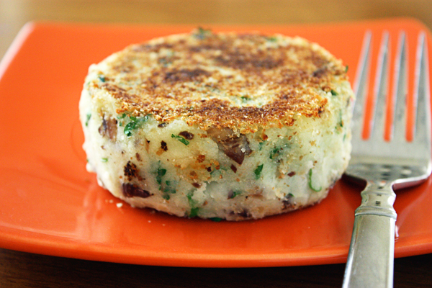

Please remember to send in your photos of you cooking the recipe and the finished product. Send pictures in to alanrtilley@mail.com or text them across to 07817777739

