Pan Haggerty Pie

Ingredients:
100g  1  2 tsp  3  4  250ml  50g  Pinch | Smoked bacon cut into strips  Sliced onion  Parsley  Medium potatoes cut into slices  Carrots, peeled and sliced  Chicken stock  Grated cheddar cheese  Salt and pepper

Method:
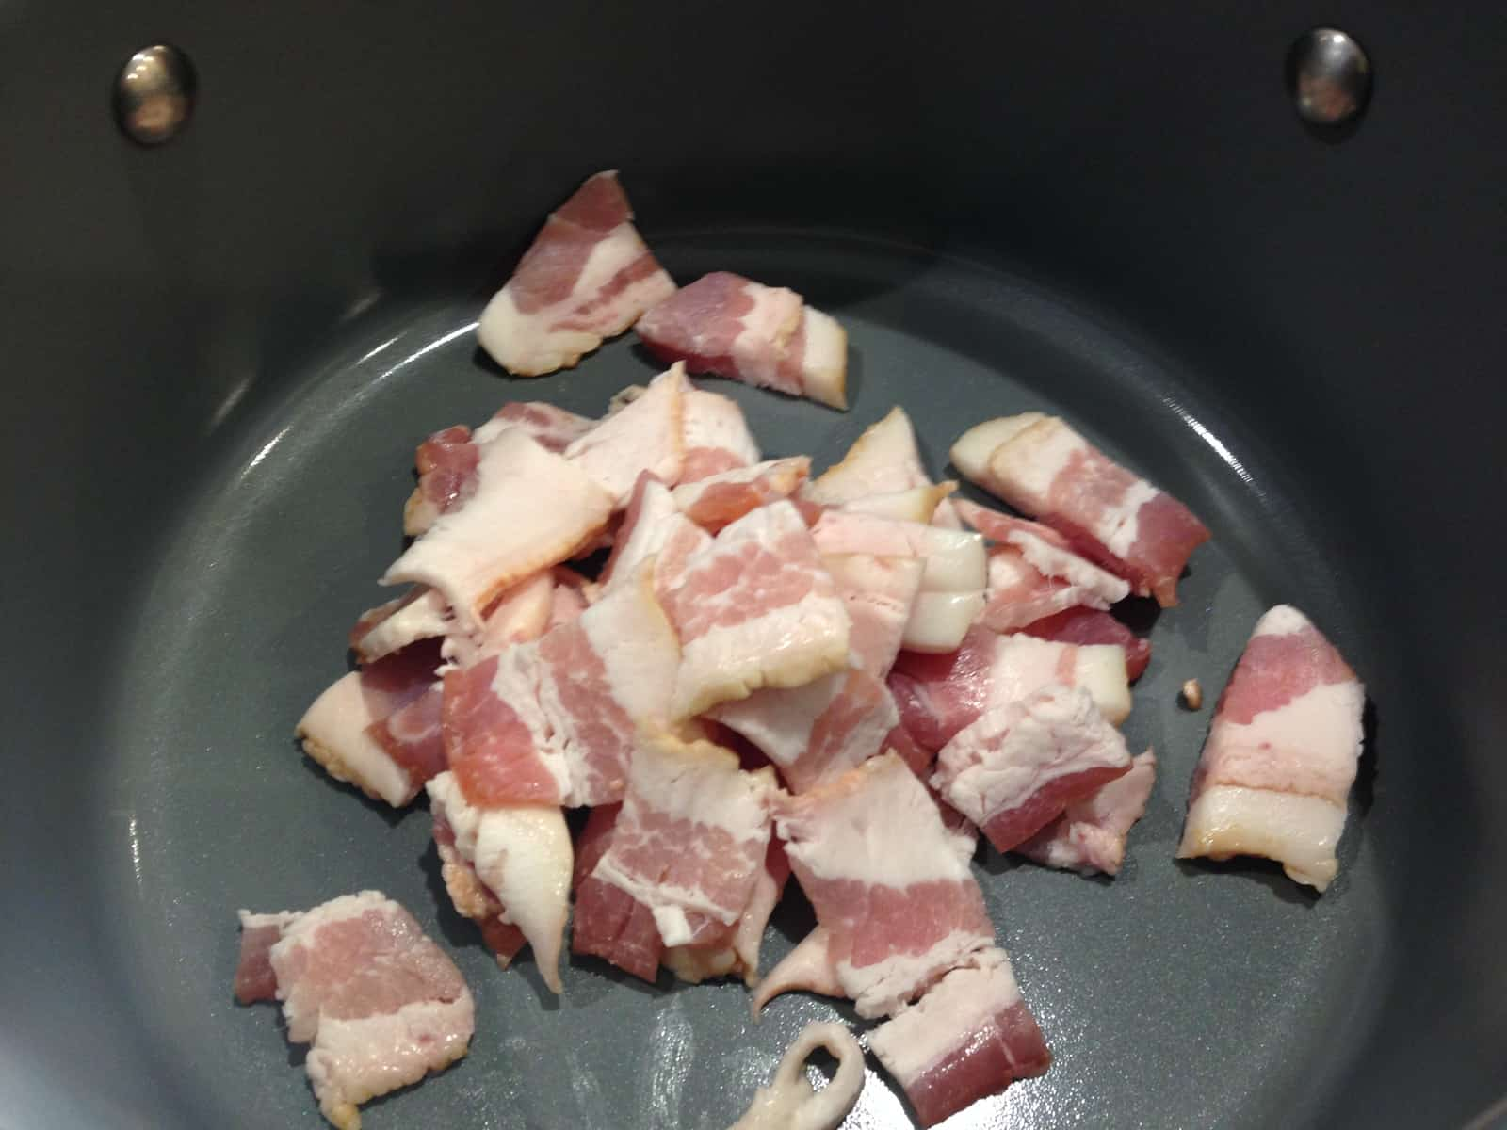
  - In a frying pan cook the strips of bacon and onion slices in a little oil and cook for 8 minutes on a low heat. After the onions are brown add the parsley and stir.
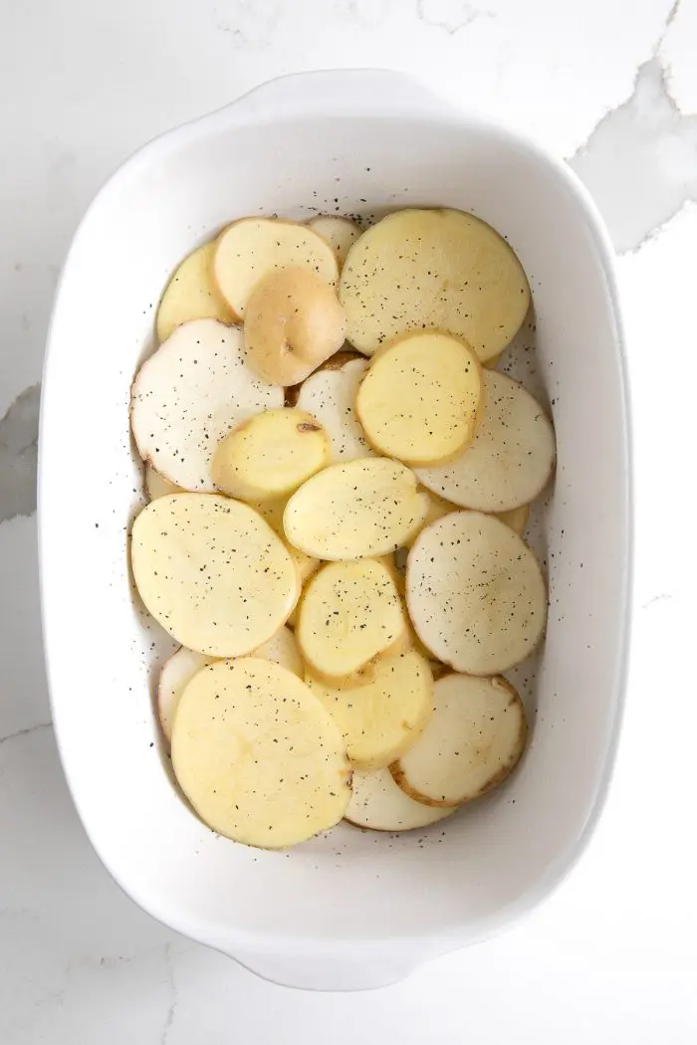
  - Next, in a small oven proof dish place half of the sliced potatoes on the base of the dish.

  - On top of the potato layer add a third of the bacon and onion mixture.

  - Then, cover the mixture with a layer of carrots. Only use up half of the carrots!

  - Next, cover the carrots with another third of the bacon and onion mixture and cover again with remaining carrots.

  - Spoon over the remaining bacon mixture and then cover with the remaining potatoes. Phew!!!

  - Pour over the chicken stock and pop in the oven for 25 minutes at 180C.

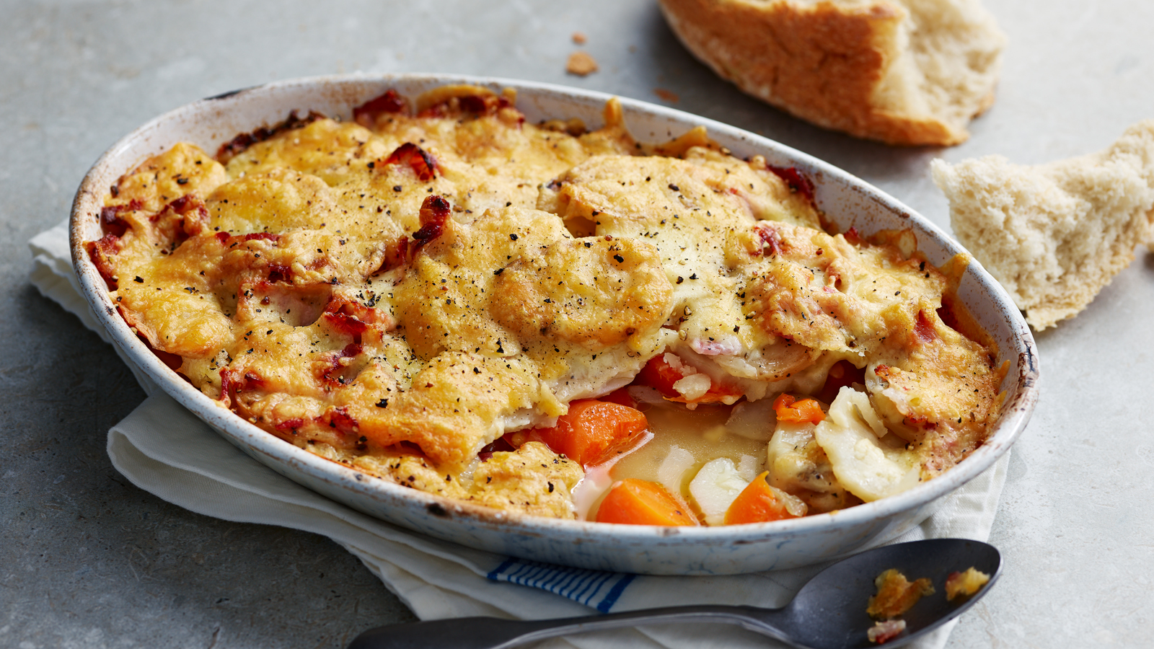
  - After 25 minutes cover with grated cheese and cook for a further 10 minutes until golden and brown.

  - Serve in a bowl and Enjoy

Please remember to send in your photos of you cooking the recipe and also the finished product. Send pictures in to alanrtilley@mail.com or text them across to 07817777739

