Mexican bean burgers

Ingredients:
1  50g  1 tsp  Bunch  1  2 tbsp  4 | Tin kidneys beans  Breadcrumbs  Mild chilli powder  Chopped coriander  Egg  Salsa  Bread rolls

Method:

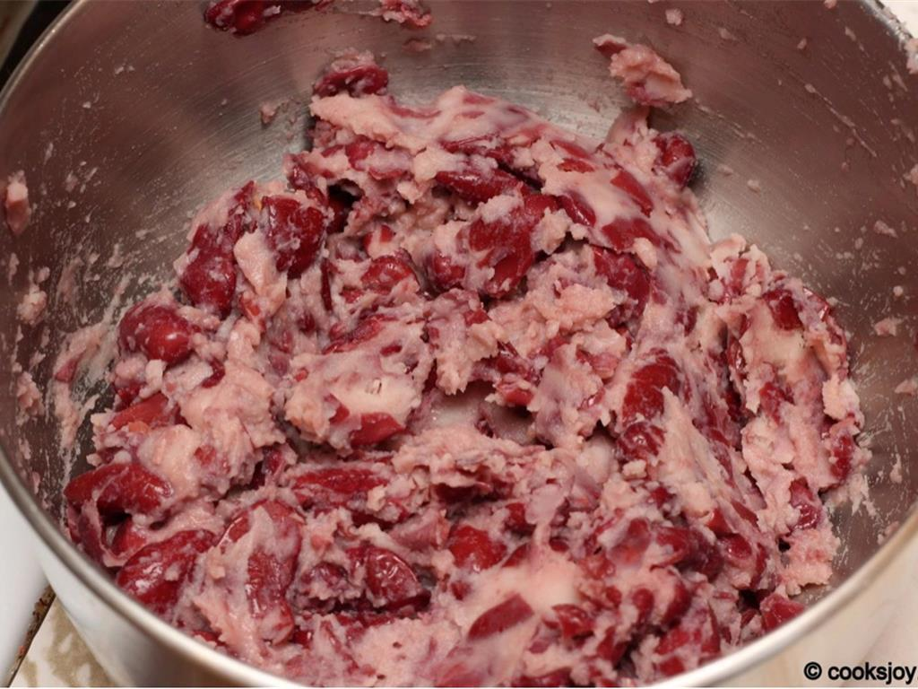
  - Drain and pour the tin of kidney beans into a mixing bowl and add to this the breadcrumbs. Using a potato masher or fork, mash the beans!

  - Add the chilli powder, chopped coriander, egg and salsa to the mixture. Mix together.

  - Bind the mixture into a large ball and then split into 4 equal pieces.

  - Roll out these smaller pieces and press down so that they form a burger shape.

  - Lightly fry on both sides for 2 minutes on a high heat.

  - Place on an oven tray and cook in an oven at 170c for 15 minutes.

  - Slice a burger bun in half, put the veggie burger in, cover with a layer of cheese and a splodge of ketchup and enjoy

Please remember to send in your photos of you cooking the recipe and also the finished product. Send pictures in to alanrtilley@mail.com or text them across to 07817777739

