Alan’s beautiful biscuits

Ingredients:
200g  200g  100g  2  75g  100g  50g | Malted milk biscuits  Unsalted butter  Caster sugar  Eggs  Plain flour  Chocolate chips  Chopped pecan nuts

Method:

  - Preheat the oven to 170C and grease the sides and base of a cake tin – at least 30cm by 20cm.
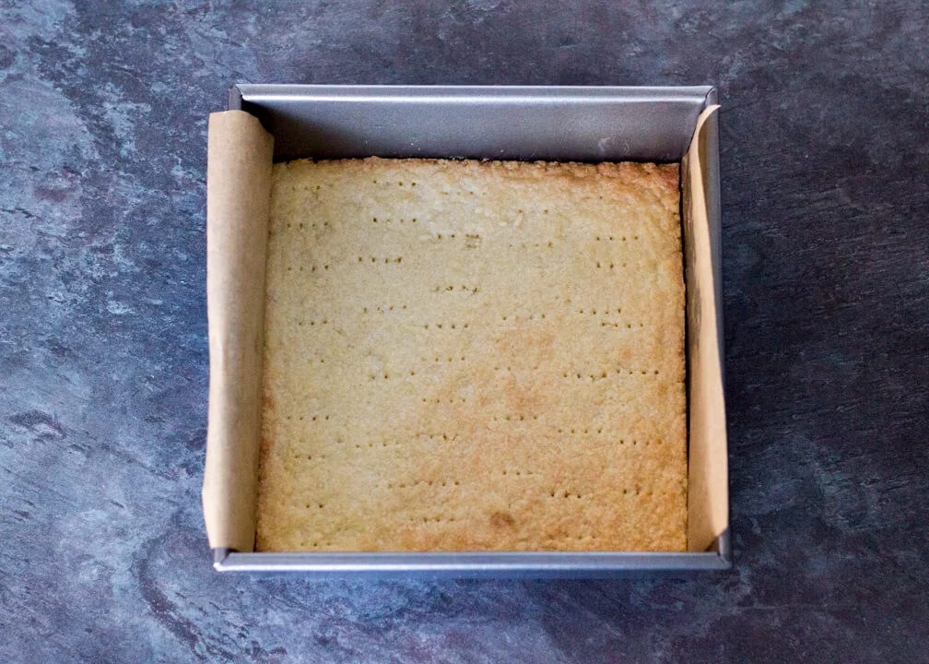
  - Crush the biscuits in a bowl and add to these 100g of melted butter. Mix and then press this mixture into the base of the cake tin.

  - Bake this base for 20 minutes and then leave to cool.
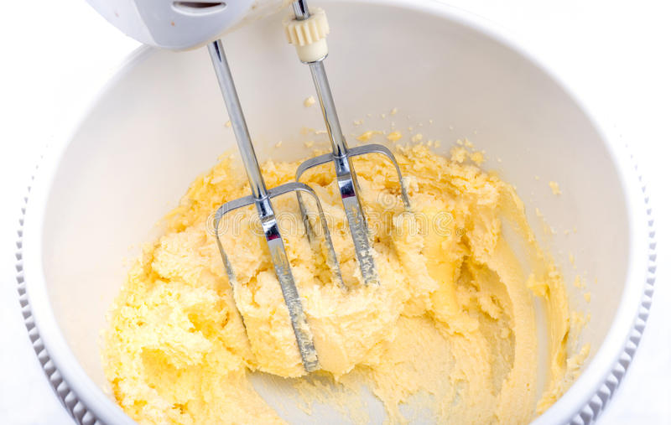
  - In a bowl mix the remaining butter, sugar, eggs, chocolate chips and pecans for 2 minutes until they are all combined.

  - Pour this mixture over the biscuit base, cook in the oven for 30 minutes and then leave to cool.

  - Cut into chunks and serve with a cuppa!

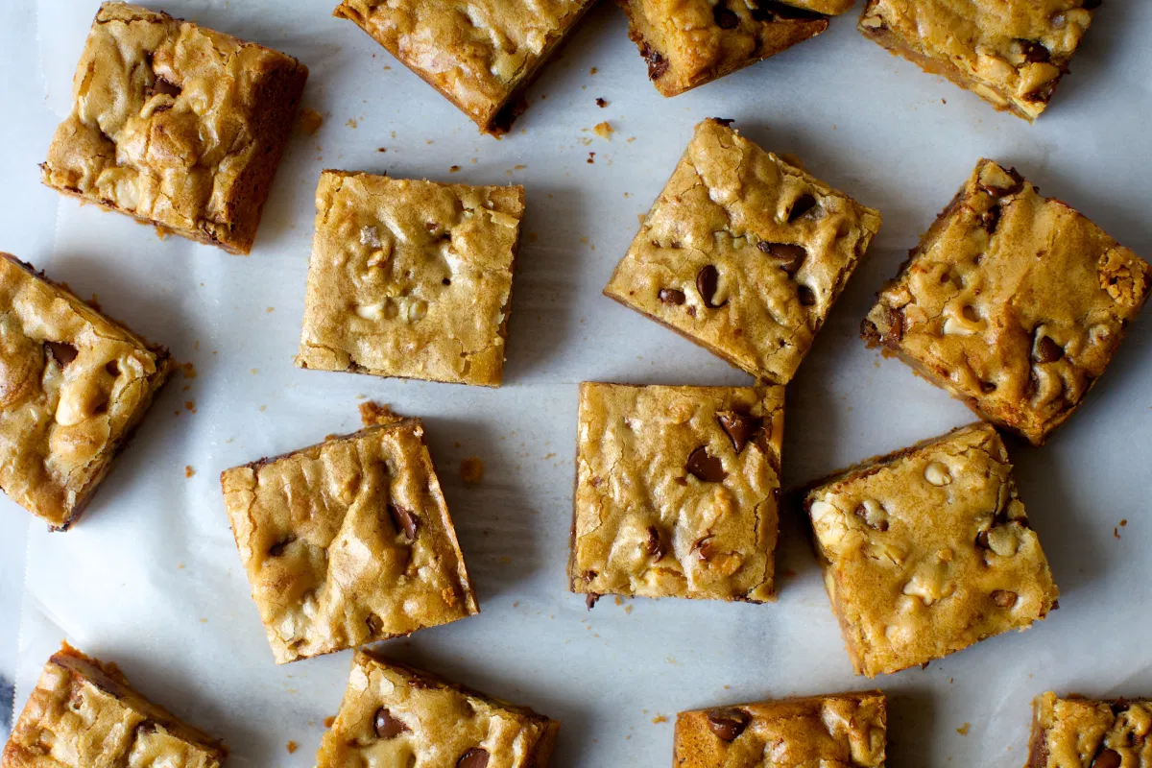

Please remember to send in your photos of you cooking the recipe and also the finished product. Send pictures in to alanrtilley@mail.com or text them across to 07817777739

