Apple and sultana muffins – Learning Disability Week 2021

Ingredients:
200g  1 tsp  1 tsp  50g  100g  2  125ml  4 tbsp  2  100g | Self-raising flour  Baking powder  Cinnamon  Wholemeal flour  Caster sugar  Eggs  Semi-skimmed milk  Sunflower oil  Grated apples  sultanas

Method:

Heat the oven

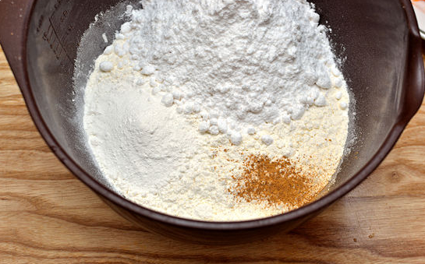

In a large bowl mix the flour, baking powder, cinnamon, and sugar

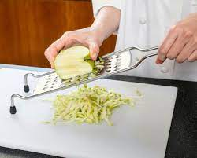
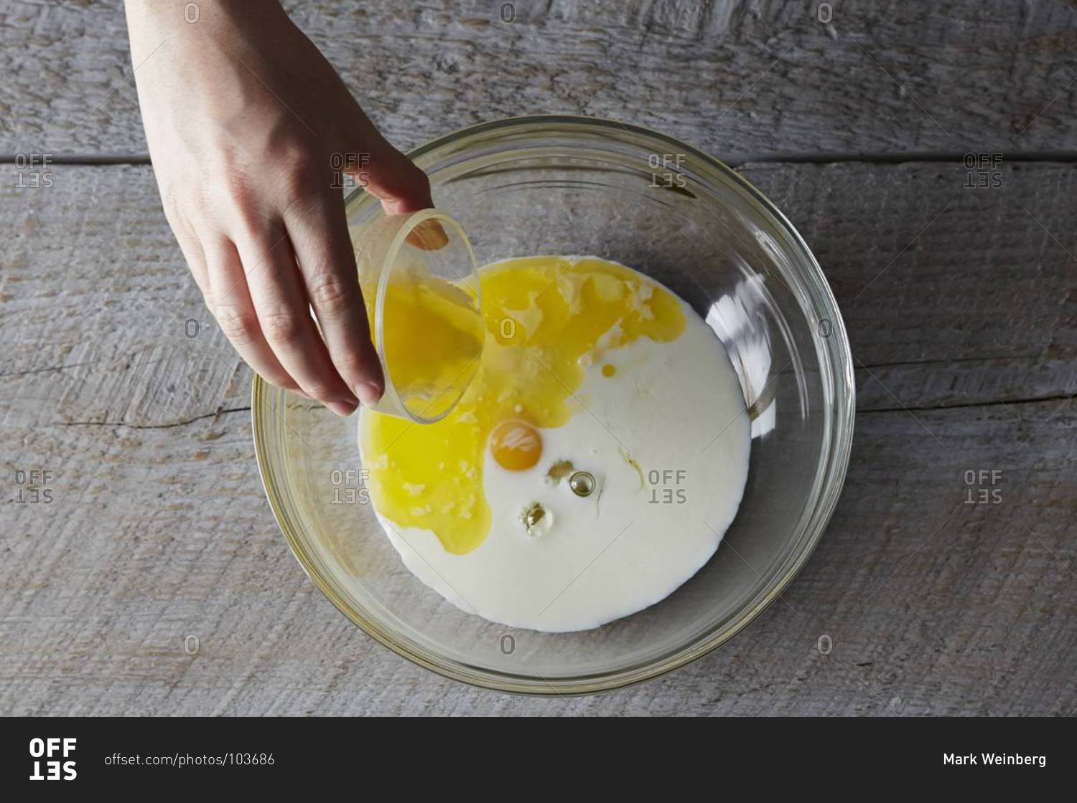
In another bowl mix the eggs, milk, and sunflower oil. Then combine the wet ingredients to the dry and add the grated apple and sultanas

Divide the mixture into 12 muffin cases and bake for 25 minutes

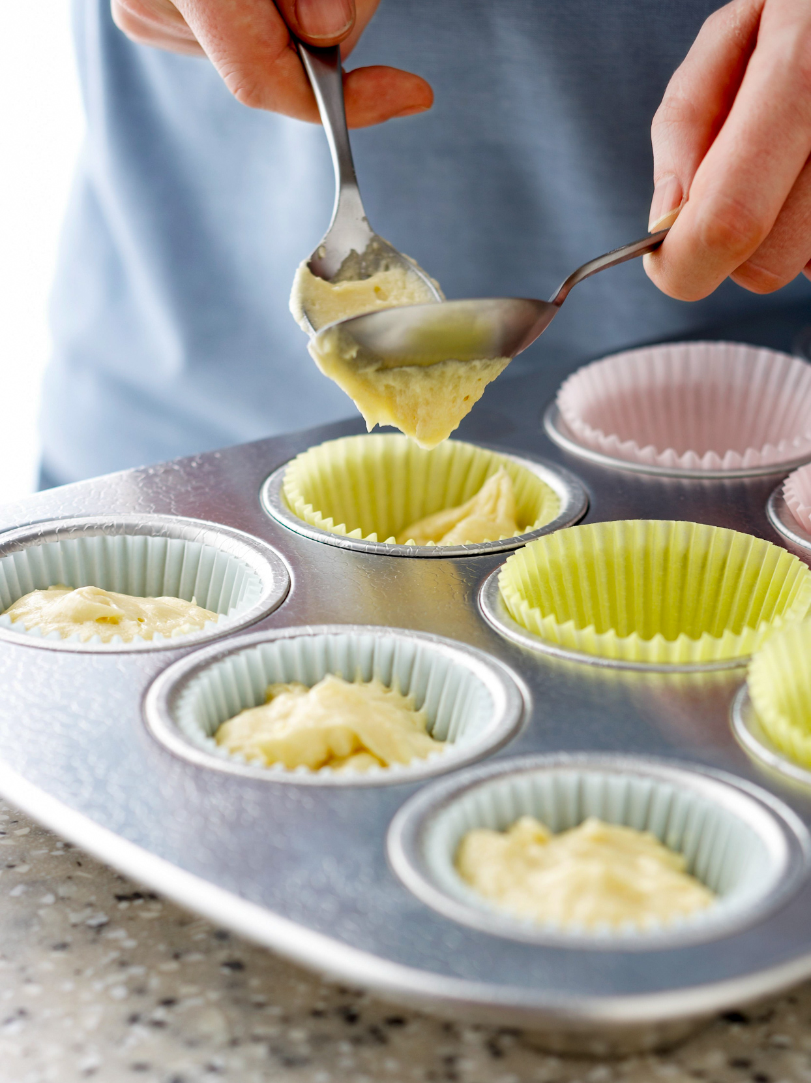

Let them cool down and then enjoy!

Please remember to send in your photos of you cooking the recipe and the finished product. Send pictures in to alanrtilley@mail.com or text them across to 07817777739

