Bacon, pea and basil pasta bake

Ingredients:
3  1  1  250g  200g  50g  1 tbsp  Bunch  10 | Chopped Rashers of streaky bacon  Chopped Leek  Tin of peas  Pasta  Soft cheese  Grated cheddar cheese  Whole grain mustard  Shredded basil  Baby tomatoes (chopped in half)

Method:

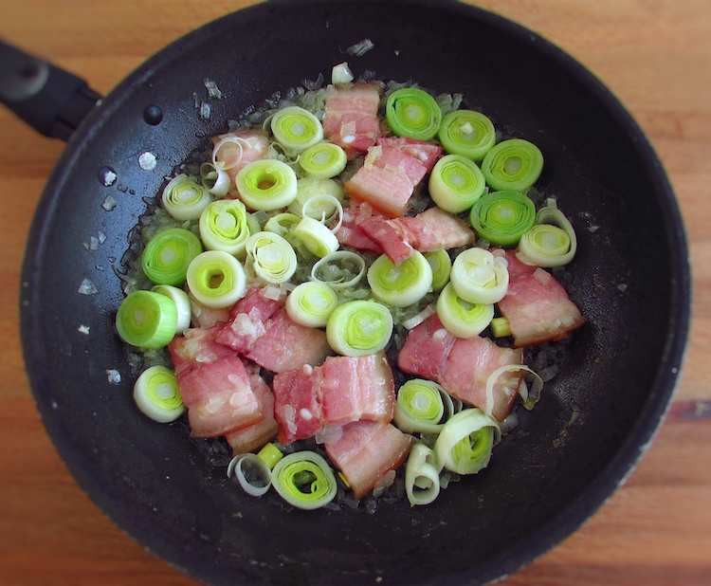
  - In a saucepan gently fry the chopped leek and bacon for 10 minutes until the bacon looks golden. Turn off the heat.
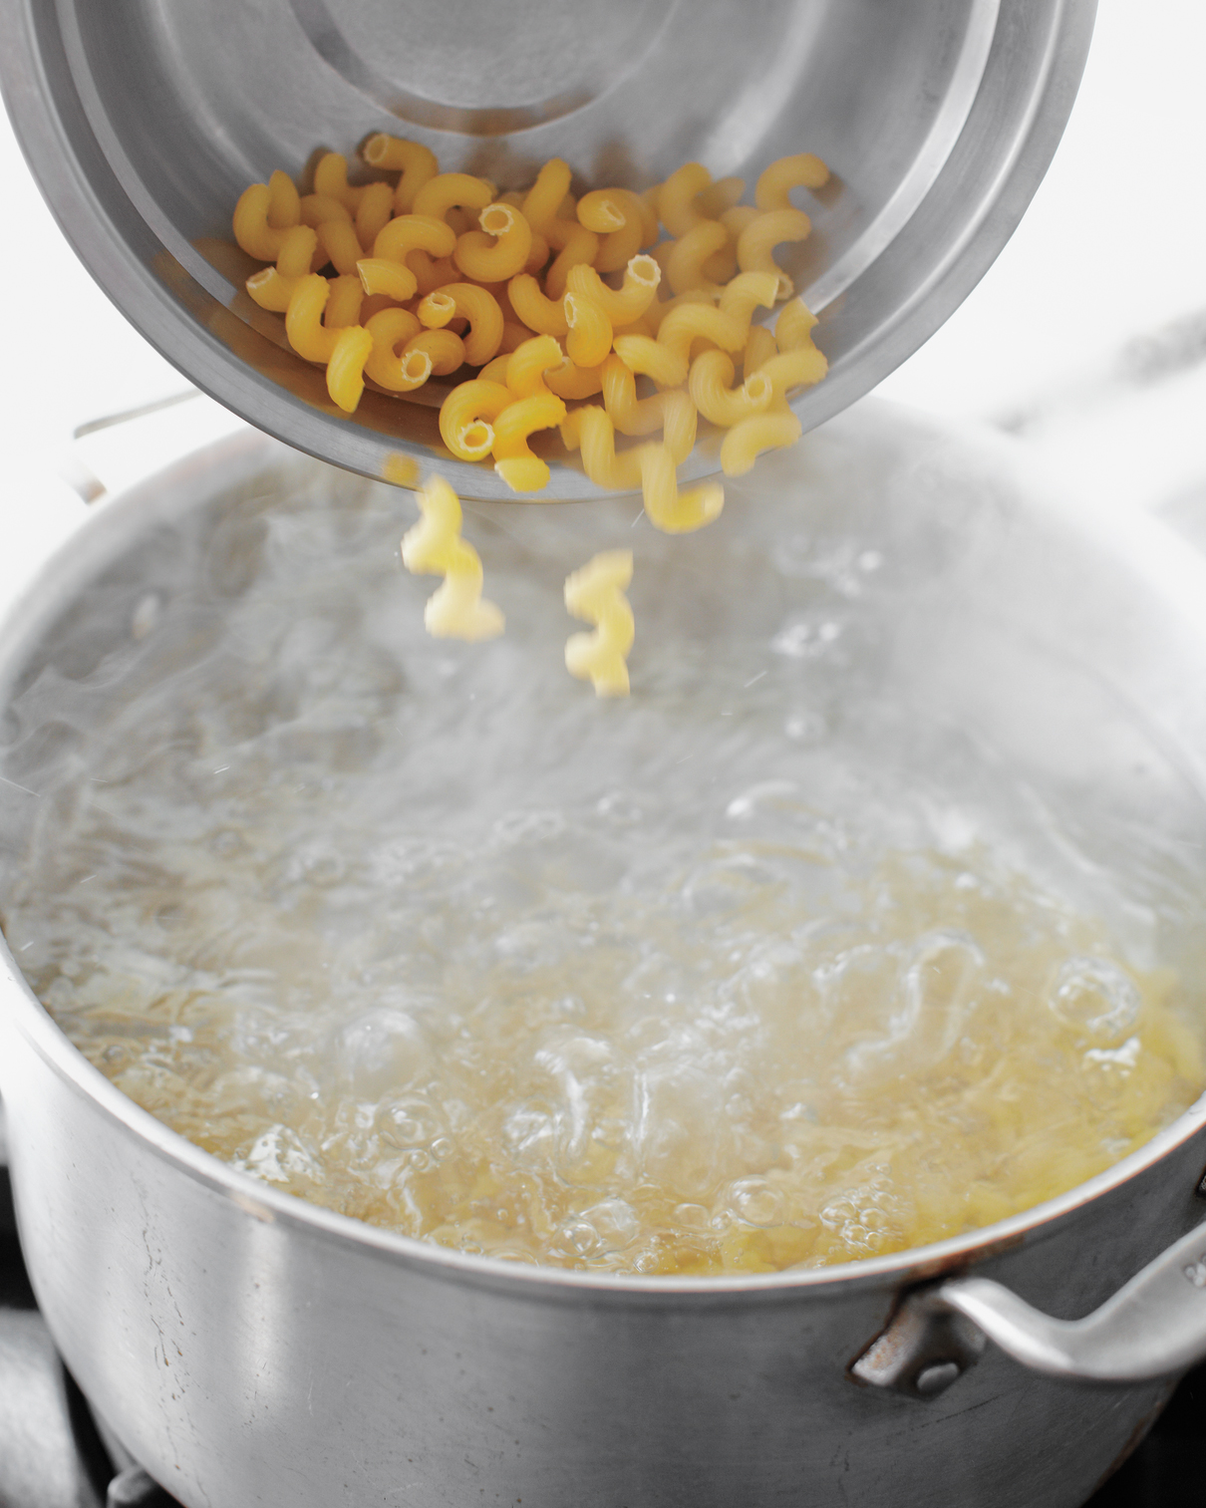

  - In a pan of cold water add a little salt and bring to the boil. Add the pasta and simmer for 10 minutes.

  - Drain and leave to one side. Pour some of the pasta water into a large cup or mug as you will need this.

  - Add the cream cheese, mustard, grated cheddar, peas and baby tomatoes to the pasta and pour over the cup of pasta water.

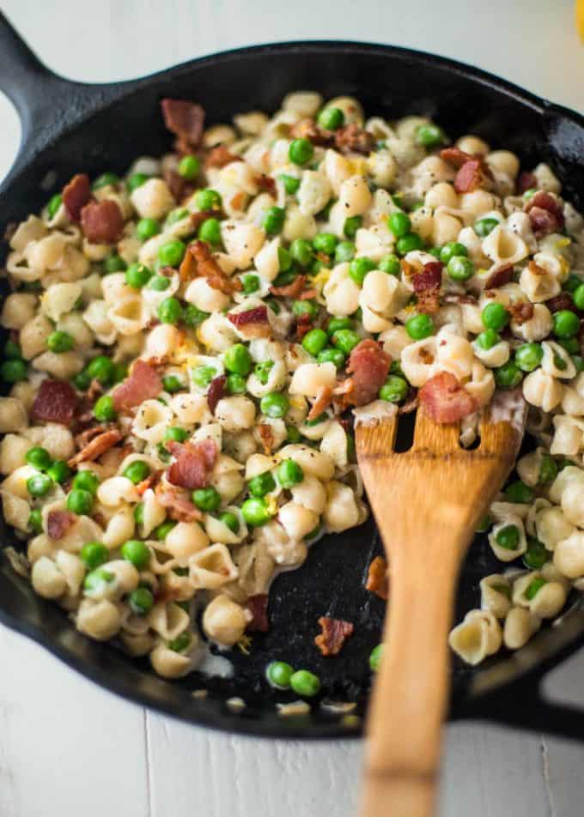
  - Then add the cooked leek and bacon.

  - Stir with a wooden spoon until everything is mixed.

  - Stir in the basil and pour everything onto an oven dish.

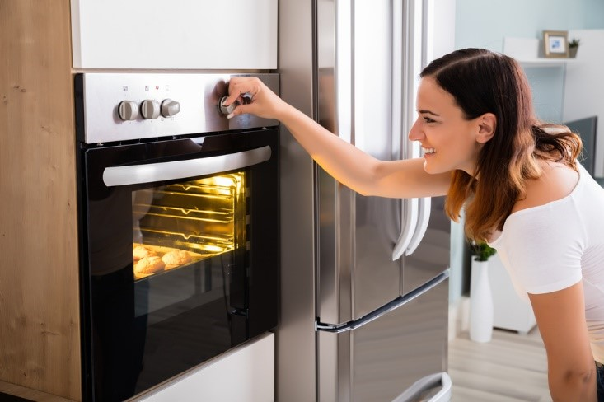
  - Bake in the oven for 20 minutes at 170C.

  - Enjoy

Please remember to send in your photos of you cooking the recipe and also the finished product. Send pictures in to alanrtilley@mail.com or text them across to 07817777739

