Mini quiches

Ingredients:
225g  100g  pinch  4  100g  2  125ml  4 | Flour  Butter  Salt  Bacon rashers or Mushrooms  Grated cheese  Eggs  Double cream  Spring onions

Method:

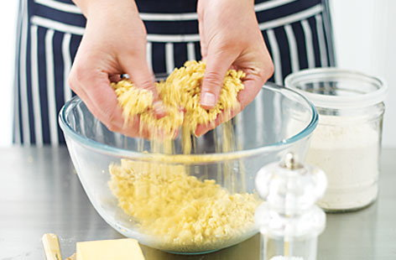
To Make the pastry-

- Sift flour into a bowl. Mix in the butter using your fingertips until it looks like breadcrumbs.

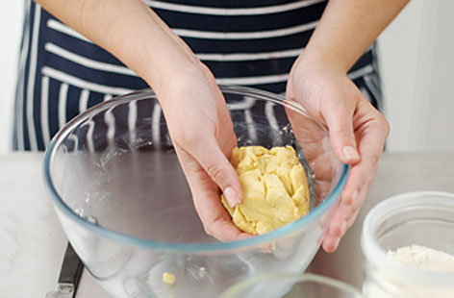
- Add pinch of salt and 3 tbsp cold water. Mix to a stiff dough. Wrap in cling film and put in the fridge for 30 minutes.

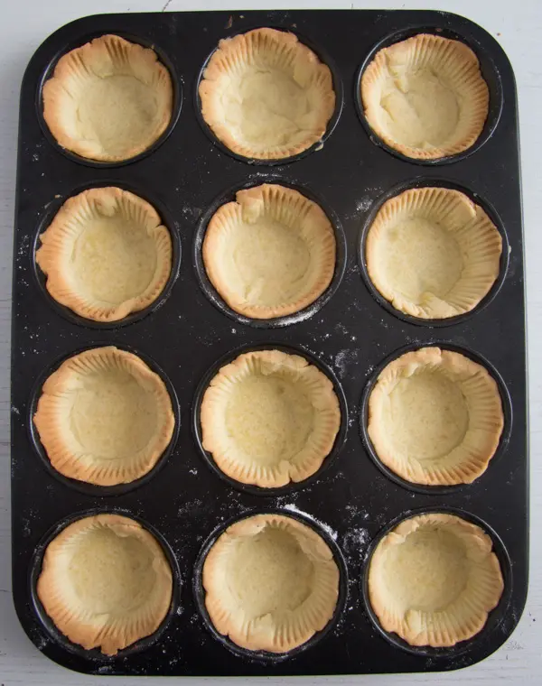
- Roll out the pastry, cut into circles using a glass or cup and press into a baking tray.

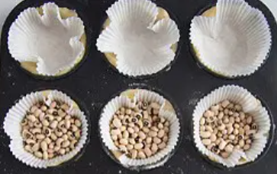
- Put a cupcake case onto the pastry and fill up with rice. Bake in an oven at 170C for 10 minutes. Leave to cool, remove rice and paper and get ready to make the insides

To make the insides of the mini quiches –

- Chop up the bacon into small pieces and fry until crispy.

- Beat the eggs into a measuring jug and add the cream and grated cheese. Add to this the crispy bacon and pour into the pastry cases.

- Bake in an oven at 170C for 25 minutes.

- Leave the cool and then enjoy

Please remember to send in your photos of you cooking the recipe and also the finished product. Send pictures in to alanrtilley@mail.com or text them across to 07817777739

