Caribbean sweet potato and bean jerk curry

Ingredients:
1  20g  Small  2 tbsp  1tsp  1 can  2 tbsp  1 tbsp  1  200g  1 can  1 | Chopped onion  Finely chopped ginger  Bunch of coriander  Jerk seasoning  Thyme  Chopped tomatoes  Red wine vinegar  Brown sugar  Vegetable stock cube  Sweet potato chopped into cubes  Black beans  Chopped Red pepper

Method:

  - In a large saucepan gently cook the onions for 5 minutes.

  - Add the chopped ginger, thyme and jerk seasoning to the onions and continue to cook for another 2 minutes.

  - Then add the chopped tomatoes, vinegar, sugar and 300ml of vegetable stock. Bring to the boil and then simmer for 5 minutes.

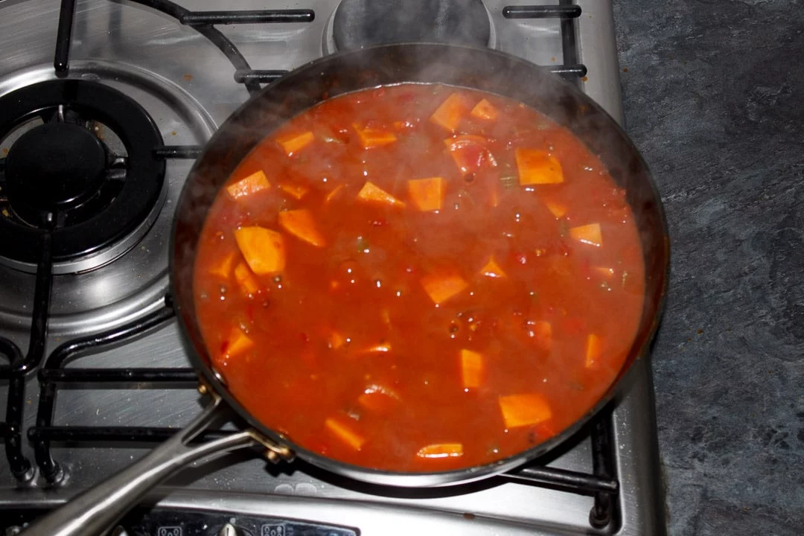
  - Stir in the sweet potato cubes and chopped red pepper and simmer for 10 minutes.

  - Add into this the beans and simmer for another 5 minutes.
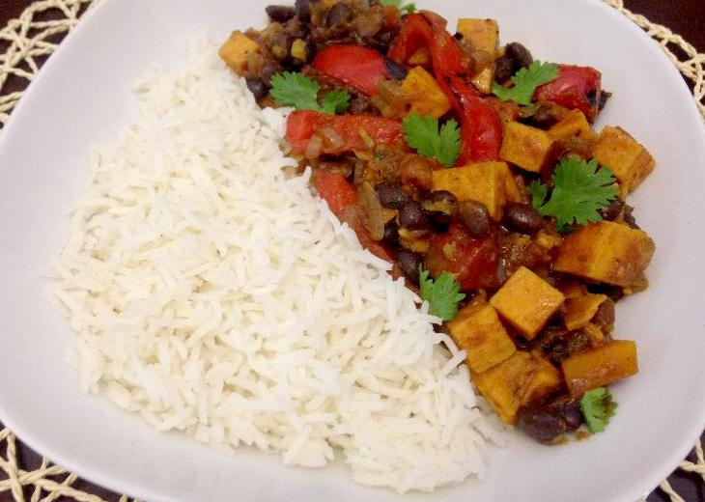
  - Serve over rice and sprinkle some coriander leaves over the top.

  - Enjoy

Please remember to send in your photos of you cooking the recipe and also the finished product. Send pictures in to alanrtilley@mail.com or text them across to 07817777739

