Chicken fajitas
Ingredients:
1  1  3  1 tsp  1 tsp  2  2 tbsp  8  150ml  100g  1  1 bunch  1 tsp  Pinch | Red pepper  Red onion  Skinless chicken breasts  Paprika  Ground cumin  Limes  Olive oil  Flour tortillas  Natural yoghurt  Cheddar cheese  Tin of chopped tomatoes  Coriander  Chilli flakes  Salt and pepper
Method:
Main
- On a chopping board carefully slice the pepper and chicken into strips and finely chop the onion.
- Put all these ingredients into a bowl, cover with the paprika, cumin and squeeze the juice of 1 lime over it. Add a little salt and pepper, mix, and leave to marinate for 5 minutes.

Salsa

- Pour a tin of chopped tomatoes into a bowl and add to this the bunch of roughly chopped coriander. Squeeze into this the juice of 1 lime and add some chillies if you want.

Get cooking!

- In a hot pan cook the chicken, pepper and onion for about 8 – 10 minutes until nice and brown (charred!!)
- Warm the tortillas in the microwave or oven and then pile in the ingredients, cover with a little salsa, a sprinkle of cheese and a little yoghurt and enjoy.
- Delicious

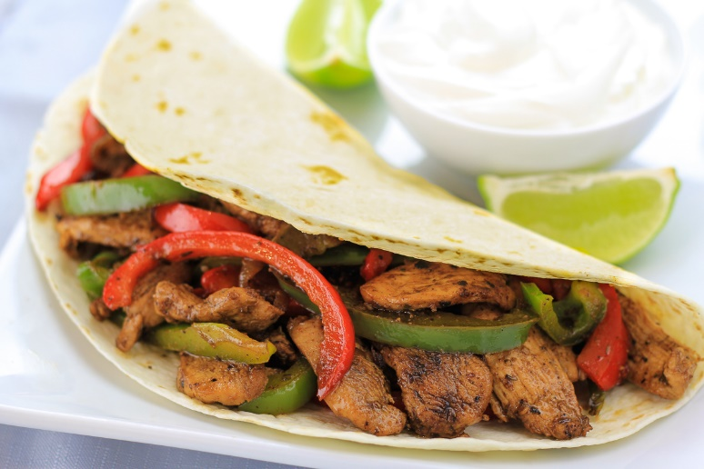

Please remember to send in your photos of you cooking the recipe and also the finished product. Send pictures in to alanrtilley@mail.com or text them across to 07817777739

I hope you are enjoying the recipes so far. We have 2 more recipes to come.

Keep sending in your photos

